CONTENTS

|  |  |
| --- | --- |
| PREINSTALLATION | 2 |
| INSTALLATION | 2 |
| OPERATION | 6 |
| SET TIMER | 7 |
| CONNECTION | 8 |
| CONNECTION SETTING TO EAM | 9 |
| CONNECTION SETTING TO SCADA INTERFACE | 11 |
| UNINSTALLATION | 13 |

PREINSTALLATION

* EAM must be active setup on BDRV & TDRV jobs
* Equipment & UOM related must be registered on EAM
* Logical meter reading only, phsical meter need modification for this application & database
* ORGANIZATION & TYPE of Target Equipment must be set according Equipment Hierarchy in company

INSTALLATION

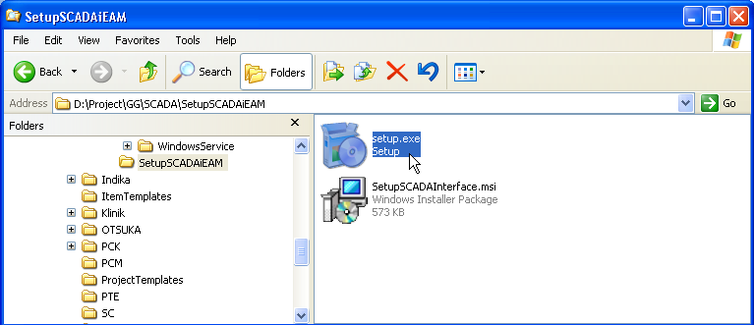

Open Installation Folder, Double Click on Setup.exe

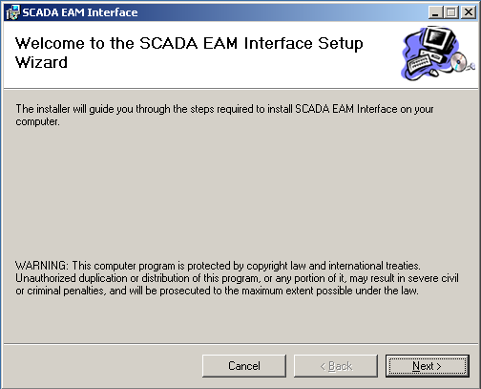

Click Next Button

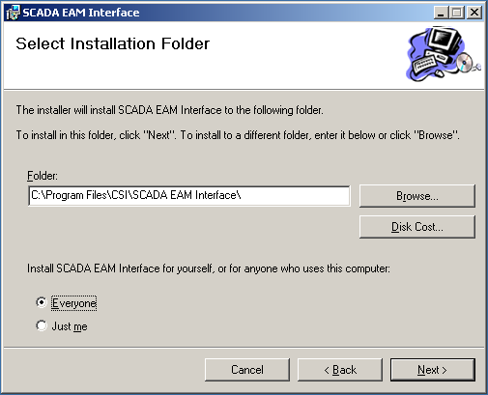

Choose for Accessing and Click Next Button.

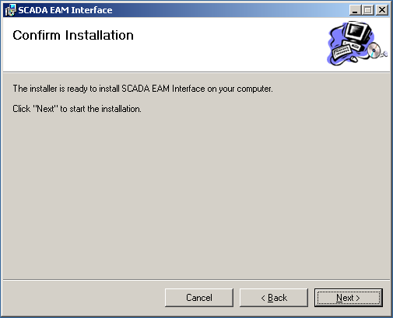

Click Next Button

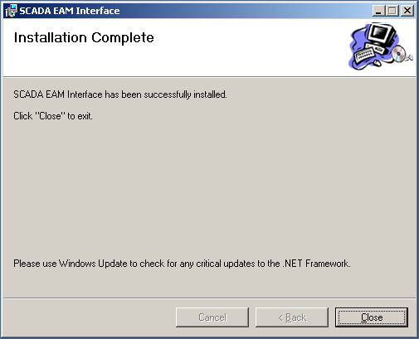

Click Close Button

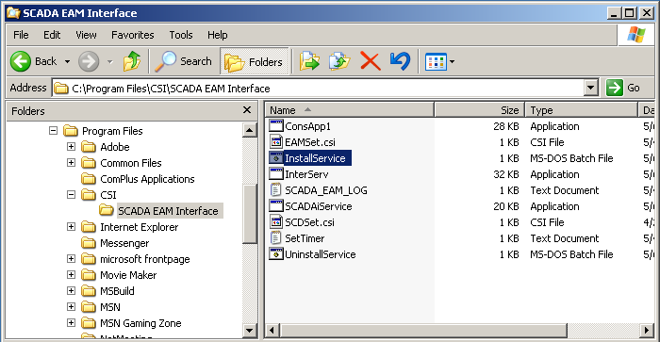

Go to Installation Folder, Double Click InstallService for Registered SCADA Interface Into EAM service in the host

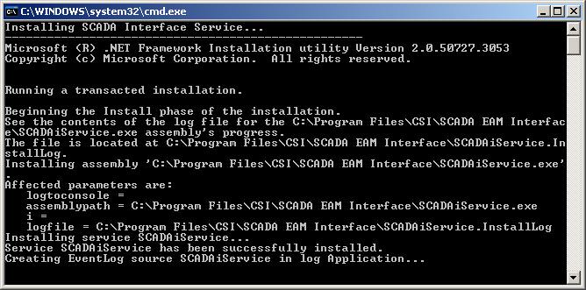

Echo of Service installation, Attention to words: Service SCADAiService has been successfully installed. That’s successfully indicator for service installed.

OPERATION

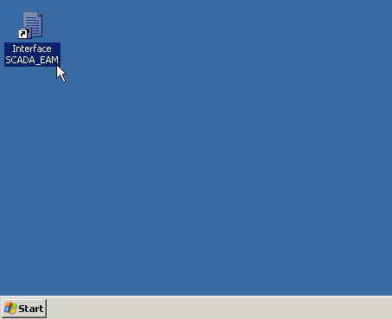

Double click Interface SCADA_EAM shortcut on desktop server

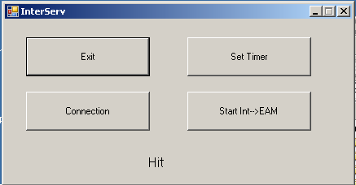

Main Menu Interface will be occurs.

EXIT : Close Or Out of Interface Application

SET TIMER : Setting menu for Windows Services SCADAiService timer in seconds

CONNECTION : Connection Setting for Interface Scada, EAM and Test Connection both.

Start Int🡪EAM : Starting or Stopping SCADA Interface Service in Windows services.If Services already running the name will be changed : Stop Int🡪EAM.

ONCE : Execution for once only

HIT : Execution Time Display

TIMER SETTING

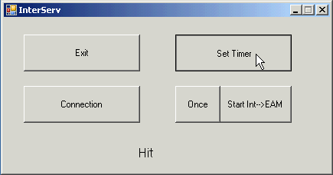

Click Set Timer button.

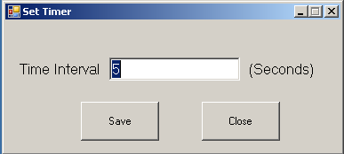

Input Execution Time Interval for Scada interface EAM Windows Service in seconds.

SAVE : Save Time Interval

CLOSE : Close Set Timer Menu

CONNECTION

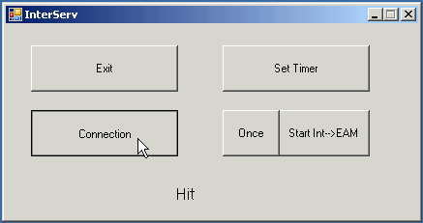

Click Connection button

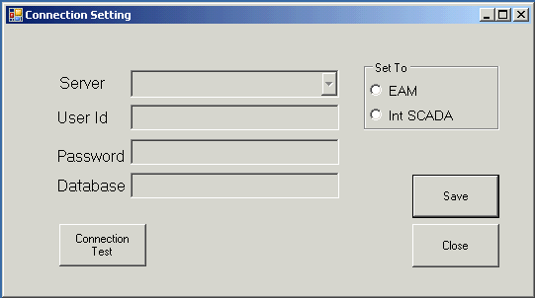

Connection Setting Menu occurs

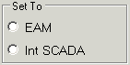: Link To Database/Server

CONNECTION TEST : Database Connection test to related link

SAVE : Save connection setting into encrypt file

CLOSE : Close Connection Setting menu

CONNECTION SETTING TO EAM

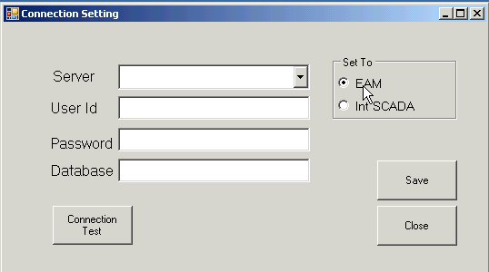

Click EAM Radiobutton on SET TO Menu, the textboxs will be unfrezee

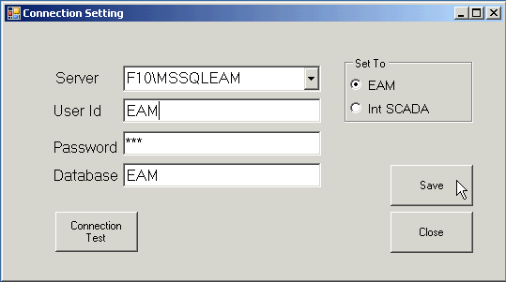

Click on combobox,select the server name and fill textbox:

SERVER : Server Name (On SQL 2008 add the instance name)

USER ID : User Id for accessing EAM Database

PASSWORD : password

DATABASE : EAM Database Name or Catalog

Click Save button

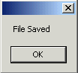

Confirmation File Saved

 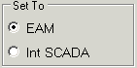

Set To EAM radiobutton and Click Connection Test button will be test Connection Setting File Saved

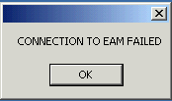 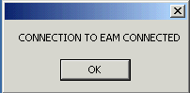

The Connection Warning will be occurs.If Failed, Resetting & saveEAM configuration file.

CONNECTION SETTING TO SCADA INTERFACE

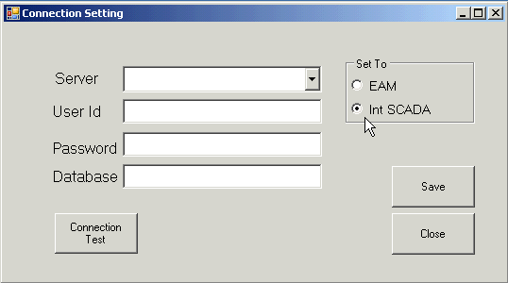

Click Int SCADA Radiobutton on SET TO Menu, the textboxs will be unfrezee

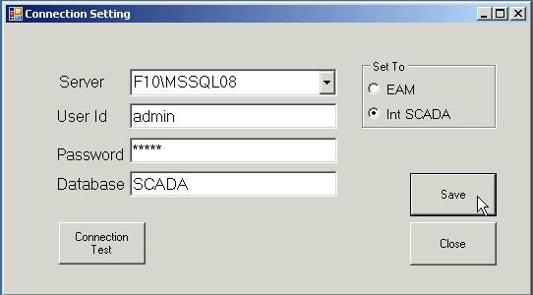

Click on combobox,select the server name and fill textbox:

SERVER : Server Name (On SQL 2008 add the instance name)

USER ID : User Id for accessing Int SCADA Database

PASSWORD : password

DATABASE : SCADA Database Name or Catalog

Click Save button



Confirmation File Saved

 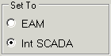

Set To Int SCADA radiobutton and Click Connection Test button will be test Connection Setting File Saved

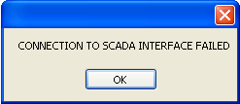 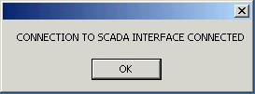

The Connection Warning will be occurs.If Failed, Resetting & saveEAM configuration file.

UNINSTALLATION

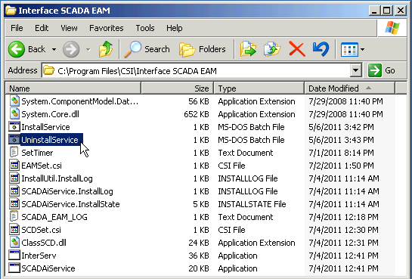

Goto Application folder,Double Click UnisntallService

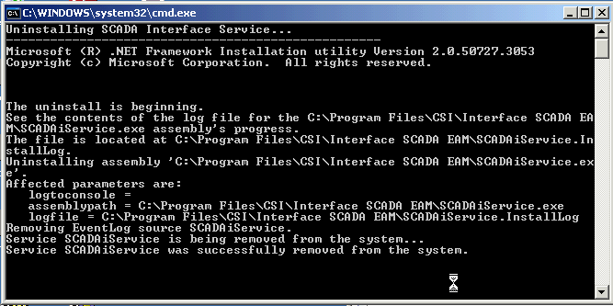

Get Attention to words:Service SCADAiService was successfully removed from the system. This step must be run first.

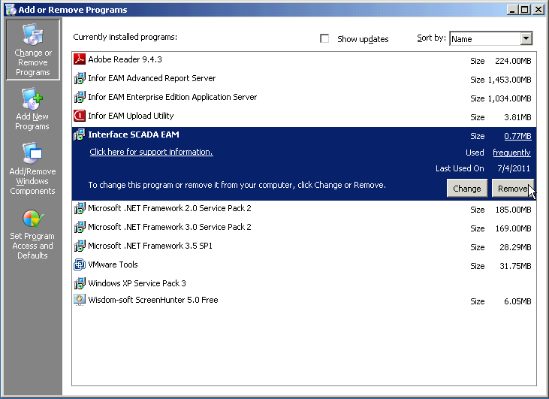

Goto Add or Remove programs, Click Interface SCADA EAM. Click Remove Button.

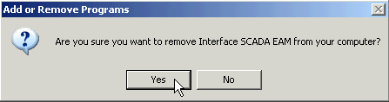

Click Yes button for remove application

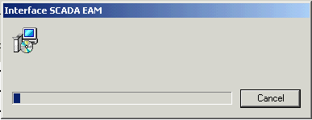

Progressing..uninstallation finished.